1. **AI-Powered Clinical Trial Chatbot an NLP-Based Solution for Personalized Healthcare Access.**
2. **Abstraction:**

Clinical trials are the standard for establishing the effectiveness and safety of treatment. The current trials are most expansive and time consuming. Emerging artificial intelligence (AI) have ability to automate the clinical process. This researcher paper aim is to make a conversational chatbot that help patients in finding relevant clinical trials to their medical history, symptoms and condition. By using advanced NLP techniques and structure database the chatbot streamlines trial recruitment, addressing accessibility challenges and enhancing patient engagement. To build this chatbot we use different framework and libraries such as python, Flask, ScispaCy and MySQL database containing 50 clinical trial protocol. The scispaCy library is a domain specific entity recognition with the help of this library we extract key medical entities like diseases, symptoms and treatment from patient input. For trial matching we employed a ruled-based filtering mechanism with the help of which we match to relevant trial stored in database. In additionally we use machine learning model which was trained on simulated patient-trial data to enhance the recommendation accuracy. This Chatbot was tasted among 200 simulated patient interaction to check performance metrics, including entity recognition accuracy, trial matching precision and recall. We check system usability and relevance of recommendations from user feedback. To understanding medical text the entity recognition achieved the F1 score of 87.5%. The precision of trial matching is 85% and recall of 90% ensuring accurate and relevant recommendations. The Chatbot achieved suitable trials for 90% of test cases, with 4.5 rating from user feedback. The important thing of this system is capable to handle diverse queries within the 10 second of response time for recommendations. The integration of scispaCy increase the efficiency of Chatbot on understanding the biomedical entity compared to other NLP models. This Chatbot successfully overcome the gap between patient and clinical trials by offering scalable, user-friendly and accurate solution. The combination of NLP and structured database simplifies the trials finding process and increase requirement efficiency.

1. **Keywords**: MySQL database, ScispaCy, conversational Chatbot, SVM, F1-Score, clinical trial, NLP, AI, Machine learning, UMLS.
2. **Introduction:**

Clinical trials play an important role to improve the medical research and health care results. [1]Due to clinical trials researchers become able to certify the capability and durability of treatment, medical drugs and medical tools. Nonetheless, having appropriate targets for the trials, has become a daunting task. The hurdles in automation of matching the data with the patients often results in delays and heavy costs. However, the advancement in Artificial Intelligence.[2] Especially NLP provides us with some promising ways to defeat these problems by providing accurate and concise results of trials-patient matching process automation. Despite having sufficient advancement in AI based Chatbot,[3] some systems are created to proficient in matching the patients to clinical trials and producing specific challenges such as complex medical terms and integration of the historical background of the patient. Present processes often fail to provide accurate solutions to the understanding of medical text and real time integration capabilities because of limitations.[4] This always raises the most important question of how an AI powered chat bot consistently automates clinical trial recommendations in the meantime giving assurances of accuracy and user friendly integration. Although AI has shown great help in the healthcare sector, nonetheless the chat bots which are produced for medical trials matching still remain under-developed. Tools which provide domain specific NLP such as ScispaCy[5]

by giving robust recommendations of algorithms are scanty. Moreover, our systems lack the appropriate method for matching patients to trials based on multi-criteria inputs, for example, history of the patient, age of the patient and symptoms of the disease.[6] Therefore, this research aims to find solutions and bridge the gaps by providing a domain-specific Chatbot which is capable of addressing the above mentioned issues. This research aims to provide a conversational AI chat bot that integrates with NLP and recommends algorithms to appropriately process the patient provided data, such as, the symptoms and medical history of the patient.[7] Match patients to most logical clinical trials, which are stored in classified database. [8] Create accurate interaction for the trials and dissemination of the acquired information. The result is that the chat bot based on domain specific NLP (e.g ScispaCy) and a well-designed suggestion algorithms shall outperform mostly the general purpose AI systems in clinical trial matching. This chat bot will combine ScispaCy-generated NLP engine with a recommended algorithm to process patient information and provide relevant trials. A MySQL database stores clinical trials and patient information in detail.[9] This system timely processes the relevant data for medical research analysis and trials by using multi-faceted decision making tools and techniques. This Chatbot proposed to be implemented in a flask, by ensuring scalability and ready to be deployed.[10] The main purpose of this study is, by providing an accurate and specialized solution for clinical trial recruitment in today’s ever-increasing field of AI in the healthcare. By finding solutions to the domain specific challenges via advanced NLP and machine learning ways.[11] This Chatbot will have the capability to make better the patient-trial matching accuracy, reduction in the recruitment time and increase the efficiency of clinical research. Therefore, this research may provide for the future use of AI in specialized medicine and large-scale healthcare sector.[12]

1. **Literature Review**

The use of artificial intelligence (AI), more especially Natural Language Processing (NLP), in automating patient-clinical trial matching is covered in this review. In order to find gaps and provide the foundation for a domain-specific Chatbot that uses scispaCy and unique recommendation algorithms, the goal is to assess the body of research on AI-driven systems for healthcare applications, with a particular focuses on Chatbot for trial recruitment.[13] According to recent report the top 3 challenges in clinical trial results are:

* Complexity of clinical trial 38%
* Study Startup 35
* Recruitment and Retention 36%
* Site Staffing 31%

In medical research clinical trial are the important aspect for the development and improvement in new treatment and drugs the process to performed clinical trial is very difficult and the challenges where occurred are listed down

* It is very difficult process to fetch the right patient which lead time consuming[14].
* Approximately about 30% of clinical trial failed to achieve desired goal due to delay or cancelation[15].
* Another challenge which they face patient retention due to delay in trial duration and demanding of protocol[16].

The important phase of clinical trial is study startup in this step decision and preparation needed to execute successful trials with the help of this remove the gap between protocol development and trial initiation[17],[18] Site Staffing is use to perform smooth clinical trial process the quality of trial and time line depend on the expertise of staff. Challenges face in site staffing is changing staff immediately which effect the trials continuity another challenge is due to the unbalancing of crew may cause work load due to which delay in multiple trials execution. Overcome the complexity in clinical trials due to the advancement of Artificial Intelligence (AI) and Natural Language Processing (NLP) by addressing this challenges[19]. Large dataset can be difficult to analyze with traditional method due to the revolution of AI use tools to analyze the dataset to match patient to relevant trials automatically[20]. To handle this challenges use flexible staffing models they need to deploy multiple staff on peak time of work or we need to move on autonomous system which handle hundreds of thousand patients at a time which is less expansive rather than deploying multiple staff and it fulfill the patients requirements and increase the patients retention due to its user friendly interface and efficiency in result[21].

* 1. **AI-NLP in healthcare**

Recent studies highlights the importance of AI-NLP in healthcare deliverance, including patients’ diagnosis and treatment[22]. When we start to use AI in healthcare communication the integration of AI in our traditional system to give next level of efficiency and accuracy to predict well accurate result[23]. In their article they developed an system and make partnership patient with health professional to provide well suited trail to the patients[24]. The disadvantage of this approach it’s required significant time, collaboration with patient and healthcare professional and required resources[25]. Chatbot serve as critical global hub for healthcare[26]. Especially in rural area there are lack of medical facilities particularly during late night. To overcome this gap, we proposed the Robotic Medical Support Chatbot system. This innovative online platform autonomously predict medical diagnosis and temporary solution 24/7[27]. This revolution overcome the lengthy medical procedure which normal patients faced to access health services now a day you can maintain your health from your personalized healthcare Chatbot easily from anywhere[28],[29] insight from this study is that it is the responsibility of government and enterprises official to boost the Chatbot adoption in society[30].

|  |  |  |  |
| --- | --- | --- | --- |
| **Application of AI-NLP in healthcare application communication** | **Description** | **Benefits** | **Challenges** |
| Virtual health assistance and Chatbot | AI-NLP base Chatbot give quick response can be used in different application to overcome human efforts like scheduling, hotel booking and in medical field also etc. | Deploy on cloud as 24/7 multiple services provider Online globally. | Difficult to recognize complexed medical entities and patents trust |
| Personalized Communication | AI-NLP proposed application provide personalized treatment on patients’ needs condition | Which lead patient engagement, satisfaction and deliverance | To manage multiple user preference and privacy |
| Language translation | Ability of AI-NLP powered application is that they can understand multiple human spoken languages which normally people can’t do | This help system to provide desired treatments to patients in efficient way | Accuracy of translation into local language is very low. |

**6 METHODOLOGY:**

In this research paper we mainly focuses on developing AI based Chatbot that make the clinical trials process easy which helpful in increasing the user engagement by making user friendly interface. To perceive accurate result we integrate our Chatbot with NLP of domain specific library and MySQL database and the step we fallow to developed this system which are mention below step by step.

* 1. **System Architecture:**

Initially we discussed about the structure of the system which we discussed one by one

**Frontend:** To create user friendly interface which make communication easy for end user. It’s also user and system interaction point.

**Backend:** This section called brain of the system because it is the section where user input can be process, retrieve data from database and recommend suitable trials the patient.

**Database**: it give us space where we stored our required resources like clinical trials, protocols. The technology we used to make this conversational Chabot **Flask** for Backend, MySQL for Database and ScispaCy used for extracting key medical entity form text.

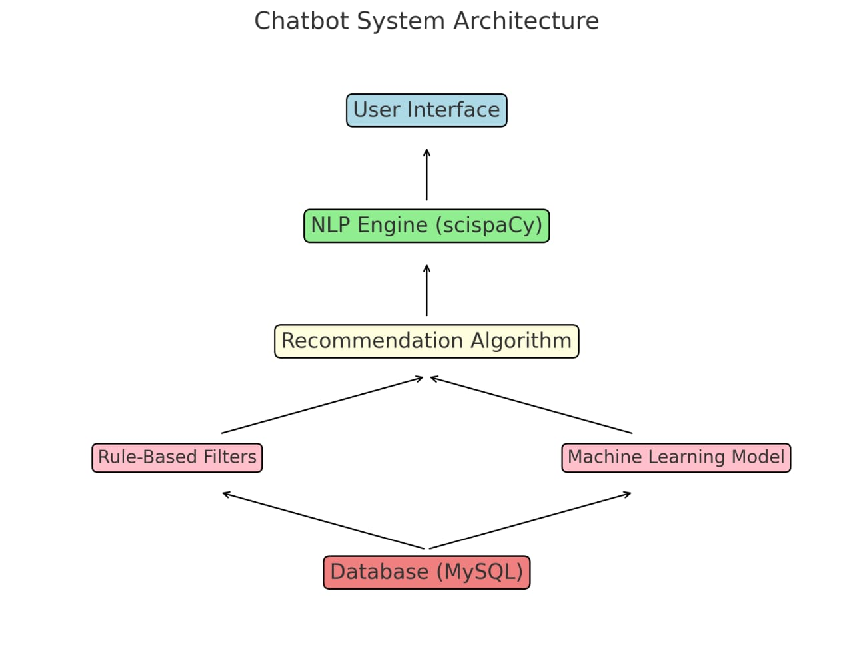

* 1. **Data Collection and preprocessing:**

Clinical Trials: Stored 50 trials including trial protocol, eligibility criteria and study locations. Medical Text: For training model we need large and accurate medical dataset for this purpose we extract dataset like UMLS and research articles. And we record the patients’ details like demography, symptoms and medical history.

We perform different preprocessing techniques to extract key information and removed irrelevant information from the data the steps which we have taken to preform preprocessing techniques like text cleaning in this techniques we try to remove irrelevant information like html tags, stopwords and special character etc. Another preprocessing step is Tokenization it is the process of breakdown the text data into sentence or word to extract meaningful information. Medical Entity recognition step in this step we used NLP pretrained model with the help of which we extract key medical entities like diseases, treatments and symptoms. Vectorization is the process of converting textual data into number this process increased the model understanding bitterly there are various techniques to perform Vectorization but we use word embedding techniques for Vectorization.

* 1. **NLP Model Development:**

We developed this clinical questioning answering Chatbot by taking set of NLP protocols to match patients with suitable clinical trials. First we need to find the information from user input like symptoms, diseases treatment and preference after performing this step we need to match the patients input to suitable clinical trials and then we need to find similarity score by using cosine similarity on the vectorized data. After performing all this step now we need to generate response which guide users in during using this Chatbot.

* 1. **Recommendation Algorithm:**

For better result we apply Machine learning and rule-based algorithm. Machine learning algorithm help in finding the best fit trial on patients’ historical data. To match user input (e.g.. age, range, disease) we were used ruled based algorithm that help in matching user input with suitable clinical trials stored in a database. For recommendation then we find evolution metrics of model F1-score, accuracy, precision and recall.

* 1. **Implementation:**

The Chatbot is composed of Flask and integration of AI-NLP and MySQL database. User give their inputs (e.g.… symptoms, age, and medical history) through the interface and then system process the input using NLP and match this input with relevant clinical trials which was stored in database and user will get detail information about trials.

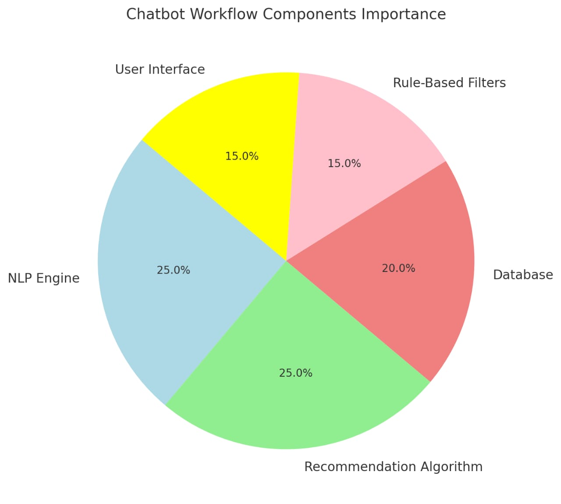

* 1. **Ethical Consideration:**

In ethical consideration privacy is the first policy by keeping in mind we ensure patient data in privacy. Our system is designed in such a way it provide information support and patient directed to heath profession for final discussions.

* 1. **Result:**

.We check system usability and relevance of recommendations from user feedback and find the evolution metrics of this system and write it down. To understanding medical text the entity recognition achieved the F1 score of 87.5%. The precision of trial matching is 85% and recall of 90% ensuring accurate and relevant recommendations. The Chatbot achieved suitable trials for 90% of test cases, with 4.5 rating from user feedback. The importing thing of this system is capable to handle diverse queries within the 10 second of response time for recommendations.

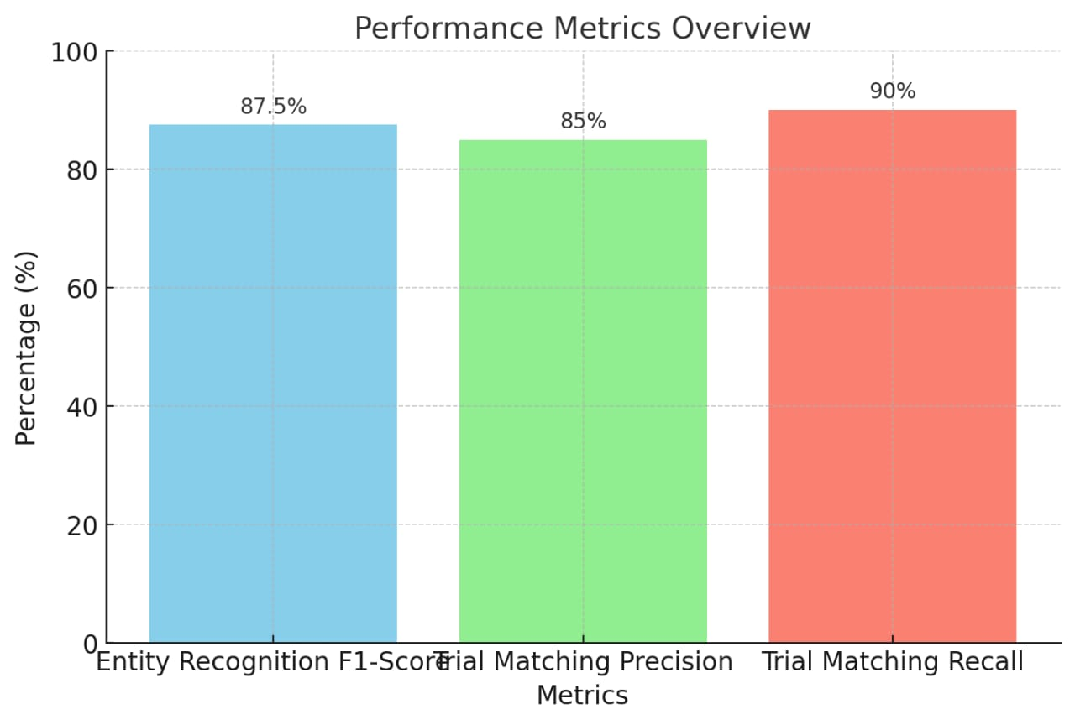

**References:**

1. [1] S. Maleki Varnosfaderani and M. Forouzanfar, "The role of AI in hospitals and clinics: transforming healthcare in the 21st century," Bioengineering, vol. 11, no. 4, p. 337, 2024.
2. [2] Y. Chen, C. U. Lehmann, and B. Malin, "Digital Information Ecosystems in Modern Care Coordination and Patient Care Pathways and the Challenges and Opportunities for AI Solutions," Journal of Medical Internet Research, vol. 26, p. e60258, 2024.
3. [3] A. Casheekar, A. Lahiri, K. Rath, K. S. Prabhakar, and K. Srinivasan, "A contemporary review on chatbots, AI-powered virtual conversational agents, ChatGPT: Applications, open challenges and future research directions," Computer Science Review, vol. 52, p. 100632, 2024.
4. [4] S. Sai, A. Gaur, R. Sai, V. Chamola, M. Guizani, and J. J. Rodrigues, "Generative ai for transformative healthcare: A comprehensive study of emerging models, applications, case studies and limitations," IEEE Access, 2024.
5. [5] E. C. Dos Reis, S. Caneppa, P. Vasconcelos, and P. C. J. de Lima Santos, "Advancing pharmacogenomics research: automated extraction of insights from PubMed using SpaCy NLP framework," Pharmacogenomics, pp. 1-6, 2024.
6. [6] N. Chemkomnerd, W. Pannakkong, T. Tanantong, V.-N. Huynh, and J. Karnjana, "A Simulation-Based Multi-Objective Optimization Framework to Enhance Patient Satisfaction: A Case Study of Ophthalmology Department Management," IEEE Access, 2024.
7. [7] S. V. Sonekar, P. V. Bagade, A. A. Jadhav, P. R. Warhade, and T. S. Balpande, "MedQ Chat Bot/AI: An intelligent health issue analysis and resolution system," in AIP Conference Proceedings, 2024, vol. 3214, no. 1: AIP Publishing.
8. [8] S. K. Gupta et al., "PRISM: Patient Records Interpretation for Semantic Clinical Trial Matching using Large Language Models," arXiv preprint arXiv:2404.15549, 2024.
9. [9] M. Liu et al., "Design and development of a disease-specific clinical database system to increase the availability of hospital data in China," Health Information Science and Systems, vol. 11, no. 1, p. 11, 2023.
10. [10] S. Aggarwal, Flask Framework Cookbook: Enhance your Flask skills with advanced techniques and build dynamic, responsive web applications. Packt Publishing Ltd, 2023.
11. [11] A. Shen and X. Liao, "SEMANTIC DEVELOPMENT AND APPLICATION BASED ON NATURAL LANGUAGE PROCESSING," WORLD WAYS AND METHODS OF IMPROVING OUTDATED THEORIES AND TRENDS, vol. 287, 2024.
12. [12] P. Esmaeilzadeh, "Challenges and strategies for wide-scale artificial intelligence (AI) deployment in healthcare practices: A perspective for healthcare organizations," Artificial Intelligence in Medicine, vol. 151, p. 102861, 2024.
13. [13] B. D. Dubois, "AI-driven Clinical Trials Optimization for Drug Discovery and Development: Applies AI algorithms to optimize the design and execution of clinical trials, accelerating drug discovery and development processes in the pharmaceutical industry," Journal of Bioinformatics and Artificial Intelligence, vol. 4, no. 1, pp. 72-83, 2024.
14. [14] R. Khan, H. Zainab, A. H. Khan, and H. K. Hussain, "Advances in Predictive Modeling: The Role of Artificial Intelligence in Monitoring Blood Lactate Levels Post-Cardiac Surgery," International Journal of Multidisciplinary Sciences and Arts, vol. 3, no. 4, pp. 140-151, 2024.
15. [15] A. Juan Ramon et al., "Development and deployment of a histopathology-based deep learning algorithm for patient prescreening in a clinical trial," Nature Communications, vol. 15, no. 1, p. 4690, 2024.
16. [16] H. Rajasimha, "The Advent of Patient-Centric Technologies to Combat the High Dropout Rates: Revolutionizing Clinical Trials: Combating Attrition in Clinical Trials: Embracing a Patient-Centric Approach Through Innovative Technologies," Telehealth and Medicine Today, vol. 9, no. 2, 2024.
17. [17] R. Dadiz, R. Jones, and R. Guillet, "Simulation as a potential tool for successful clinical trial initiation," Journal of Clinical and Translational Science, vol. 8, no. 1, p. e109, 2024.
18. [18] A. E. Cramer et al., "Defining methods to improve eSource site start-up practices," Contemporary Clinical Trials Communications, vol. 42, p. 101391, 2024.
19. [19] P. N. K. Sarella and V. T. Mangam, "AI-driven natural language processing in healthcare: transforming patient-provider communication," Indian Journal of Pharmacy Practice, vol. 17, no. 1, 2024.
20. [20] P. K. Pandey, M. Likhariya, J. Bhadoria, K. Vinchurkar, and P. Jain, "Role of Artificial Intelligence in Drug Product Design and Optimization of Process Parameters," AI Innovations in Drug Delivery and Pharmaceutical Sciences; Advancing Therapy through Technology, p. 163, 2024.
21. [21] O. O. Madandola et al., "The relationship between electronic health records user interface features and data quality of patient clinical information: an integrative review," Journal of the American Medical Informatics Association, vol. 31, no. 1, pp. 240-255, 2024.
22. [22] D. A. Reddy, V. Rama Raju, and G. Narsimha, "Deep Brain Stimulation Coding in Parkinson’s: An Evolving Approach," IETE Journal of Research, vol. 69, no. 7, pp. 4032-4046, 2023.
23. [23] S. A. Alowais et al., "Revolutionizing healthcare: the role of artificial intelligence in clinical practice," BMC medical education, vol. 23, no. 1, p. 689, 2023.
24. [24] B. Khan et al., "Drawbacks of artificial intelligence and their potential solutions in the healthcare sector," Biomedical Materials & Devices, vol. 1, no. 2, pp. 731-738, 2023.
25. [25] R. Berardi et al., "Benefits and limitations of a multidisciplinary approach in cancer patient management," Cancer management and research, pp. 9363-9374, 2020.
26. [26] J. M. Noble et al., "Developing, implementing, and evaluating an artificial intelligence–guided mental health resource navigation chatbot for health care workers and their families during and following the COVID-19 pandemic: protocol for a cross-sectional study," JMIR Research Protocols, vol. 11, no. 7, p. e33717, 2022.
27. [27] P. Nama, P. Reddy, and S. K. Pattanayak, "Artificial Intelligence for Self-Healing Automation Testing Frameworks: Real-Time Fault Prediction and Recovery," Artificial Intelligence, vol. 64, no. 3S, 2024.
28. [28] M. Clark and S. Bailey, "Chatbots in Health Care: Connecting Patients to Information," Canadian Journal of Health Technologies, vol. 4, no. 1, 2024.
29. [29] A. Olushola, J. Mart, and V. Alao, "IMPLEMENTATIONS OF ARTIFICIAL INTELLIGENCE IN HEALTH CARE."
30. [30] T. Chen, M. Gascó-Hernandez, and M. Esteve, "The Adoption and Implementation of Artificial Intelligence Chatbots in Public Organizations: Evidence from US State Governments," The American Review of Public Administration, vol. 54, no. 3, pp. 255-270, 2024.